August 22, 2023

New in CAPS® 4.42 for Tempered Air Products (TAP)

Join us for a webinar covering the exciting topics below and more!

- New direct drive fan option expanded for make-up air models DGX & MSX into housing 35.
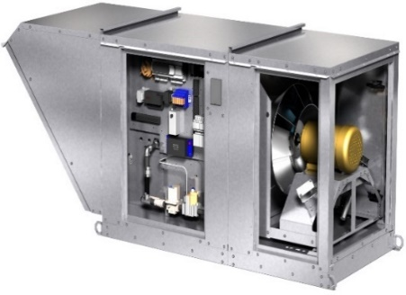
- Calculate system can now be used to configure DGX 80/20 recirculation units.
- Base package has been restructured to encompass a wider variety of selections and configurations.
- List pricing has been restructured for DGX housings H05 through H35.
- Updated electrical connection drawings for Housing H12 through H32 for DGX, IGX, MSX, and VSU models.
- Microprocessor controls are now available for
DGX-H05.
- Forward-curved fans on DGX and MSX units housing H12-H35 and IGX units with housings
H12-H32 have been discontinued and can no longer be selected or ordered.
- Backward-inclined plenum fans on DGX and MSX housings H12-H35 have been discontinued and can no longer be selected or ordered.
- Models KSFB, KSFD, and MSF have been discontinued and can no longer be selected or ordered.

Day | Date | Time | Meeting ID
Tuesday | August 22 | 1:00 PM CDT | 957 1410 0216  Double-click icon to add to calendar
Thursday | August 24 | 10:00 AM CDT | 913 4070 5817
 |  |  | Double-click icon to add to calendar
It’s easy to participate
- Select the date and time of the webinar that you would like to attend
- Click the “Join meeting” link.
- Join meeting 1: https://greenheck.zoom.us/j/95714100216
- Join meeting 2: https://greenheck.zoom.us/j/91340705817
- You may log on up to 5 minutes before the start of the webinar.

If you have any problems logging on or if you have suggestions for future TAP topics, please contact Sam Armstrong at samuel.armstrong@greenheck.com

