April 4, 2023

New in CAPS® 4.41 for Tempered Air Products (TAP)

Join us for a webinar covering the exciting topics below and more!

- New direct drive fan option for Make-Up Air models DGX & MSX
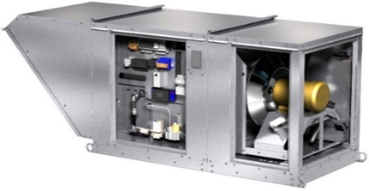
- Forward curved and backward inclined plenum fans have started the discontinuation process
- The models KSFB, KSFD, and MSF have begun the discontinuation process
- 25 Day Quick Build options are now available for DGX and MSX H35 units
- New ½ hp blower motors for MiniCore-5
- Expanded air performance on all Mini models
- Added FEI (Fan Energy Index) for most models
- All preheaters now have an extended lead time

Day | Date | Time | Meeting ID
Tuesday | April 4 | 1:00 PM CDT | 921 4244 6691  Double-click icon to add to calendar
Thursday | April 6 | 10:00 AM CDT | 936 0492 6424
 |  |  | Double-click icon to add to calendar
It’s easy to participate
- Select the date and time of the webinar that you would like to attend
- Click the “Join meeting” link.
- Join meeting 1: https://greenheck.zoom.us/j/92142446691
- Join meeting 2: https://greenheck.zoom.us/j/93604926424
You may log on up to 5 minutes before the start of the webinar.

If you have any problems logging on or if you have suggestions for future TAP topics, please contact Sam Armstrong at samuel.armstrong@greenheck.com

